Subscribe to DeepL Pro to edit this document.
Visit www.DeepL.com/profor more information.
SAFETY MANAGER: IOT SERVICE TO ENSURE THE GOOD PERFORMANCE OF MACHINES AND CONTROLS IN THE DIGITAL FACTORY
Miren Illarramendi- Doctor in Engineering
Asier Iriarte, Computer Engineering Student
Aitor Arrieta - PhD in Engineering
Goiuria Sagardui - PhD in Engineering
Felix Larrinaga - PhD in Engineering

Dept. of Electronics and Computer Science, Escuela Politécnica Superior, Mondragon Unibertsitatea, Goiru 2, E20500 Mondragon

Tel. 637466392 millarramendi@mondragon.edu
Received: DD/MM/YYY - Revised: DD/MM/YYY -- Accepted: DD/MM/YYY - DOI: https://dx.doi.org/10.6036(To be filled in by the Editor)
SAFETY MANAGER: IOT SERVICE TO ASSURE THE SAFE BEHAVIOUR OF MACHINES AND CONTROLS IN THE DIGITAL INDUSTRY
ABSTRACT:  The digital industry requires increasingly complex and reliable software systems. They need to control and make critical decisions at runtime. As a consequence, the verification and validation of these systems has become a major research challenge. At design and development time, model testing techniques are used while run-time verification aims at verifying that a system satisfies a given property. The latter technique complements the former. The solution presented in this paper targets embedded systems whose software components are designed by state machines defined by Unified Modelling Language (UML). The CRESCO (C++ REflective State-Machines based observable software COmponents) platform generates software components that provide internal information at runtime and the verifier uses this information to check system-level reliability/safety contracts. The verifier detects when a system contract is violated and initiates a safeState process to prevent dangerous scenarios. These contracts are defined by internal information from the software components that make up the system. Thus, as demonstrated in the tested experiment, the robustness of the system is increased. All software components (controllers), such as the verifier, have been deployed as services (producers/consumers) of the Arrowhead IoT platform: the controllers are deployed on local Arrowhead platforms (Edge) and the verifier (Safety Manager) is deployed on an Arrowhead platform (Cloud) that will consume controllers on the Edge and ensure the proper functioning of the plant controllers.  Keywords: run-time monitoring, robustness, software components, contracts, software models, state machines | SUMMARY:  The digital industry requires increasingly complex and reliable software systems. They need to control and make critical decisions at runtime. As a consequence, verification and validation of these systems has become a major research challenge. At design and development time, model testing techniques are used while run-time verification aims at verifying that a system satisfies a given property. The presented solution targets embedded systems whose software components are designed by state machines defined by Unified Modelling Language (UML). The CRESCO (C++ REflective State-Machines based observable software COmponents) platform generates software components that provide internal information at runtime and the verifier uses this information to check system level reliability/safety contracts. The verifier detects the violation of a system contract and initiates a safeState process preventing dangerous scenarios. These contracts are defined by internal information from the software components that make up the system. Thus, as demonstrated in the tested experiment, the robustness of the system is increased. All software components (controllers), such as the verifier, have been deployed as services (producers/consumers) of the IoT Arrowhead platform: the controllers are deployed on local Arrowhead platforms (Edge) and the verifier (Safety Manager) is deployed on an Arrowhead platform (Cloud) that consumes controllers on the Edge and ensures the proper functioning of the plant controllers.  Keywords: Runtime monitoring, robustness, software components, contracts, software models, state machines.
1.- INTRODUCTION
Software is increasingly taking on the responsibility for providing functionality in systems. As a consequence, these software systems are becoming increasingly complex. Cyber Physical Systems (CPS) are increasingly talked about. These systems usually take control of the physical part (sensors, actuators, real physical world) via software.

As Koopman [1] says, SCPs are vulnerable to specification, design and performance defects. Verification and validation techniques applied during design and development provide a certain level of confidence in the correctness of the system. However, we need systems that detect and mitigate dangerous and uncertain scenarios in operation.

Information on the internal state of a system's software components can anticipate the detection of dangerous system operation. By analysing this information, corrective measures can be taken and faulty scenarios can be prevented. In [2] and [3] this idea is described as "safetyBag".

In the current scenario, where the digitisation of industry is taking promising steps and we are talking about digital twins and 5G technology improves the reliability and speed of communications, we believe that real-time verifiers to increase process robustness will opt to be presented as solutions in the form of services deployed on IoT platforms. Along these lines, this work proposes the automatic generation of reflective controllers and their verifiers and offer them as services on an IoT platform at runtime.

The approach has been validated on a system consisting of a Robotic Arm Motion Controller and its Motor Controller. The main contributions are:

- verify security contracts at system level by monitoring the internal status of software components,
- avoid errors before a change in the status of software components occurs,
- isolate system and verifier functionality without interfering with design and development work.
- deploy the controllers and verifier on the Arrowhead IoT platform demonstrating their utility.

To demonstrate these contributions, experiments have been carried out with the aim of answering the following research questions (RQs):

PI1: Is RCC an effective tool for detecting errors and unreliable runtime scenarios?

PI2: Does the servitisation of controls and verifiers in the Edge/Cloud help to increase the reliability of systems in industrial plants?

Section II presents previous work and Section III presents both the CRESCO framework for the automatic generation of software components and the Runtime Contract Checker (RCC) at runtime. The deployment of the solution on an IoT platform is also explained. Section IV presents the empirical evaluation and results. Finally, Section V concludes the paper with conclusions and future directions.

2.- PREVIOUS WORKS
One way to perform run-time verification is to look at the information/traces sent by the software driver to the outsourced verifier.
Current real-time verification solutions are specified at different levels of abstraction: system, component, class, method or statement. As Figure 1 shows, most approaches perform verification at the same level, i.e. only by checking system level properties can system misbehaviour be detected. However, component level properties can provide valuable information to detect system level problems and the first contribution of this paper focuses on demonstrating this fact and offering a solution capable of doing so.
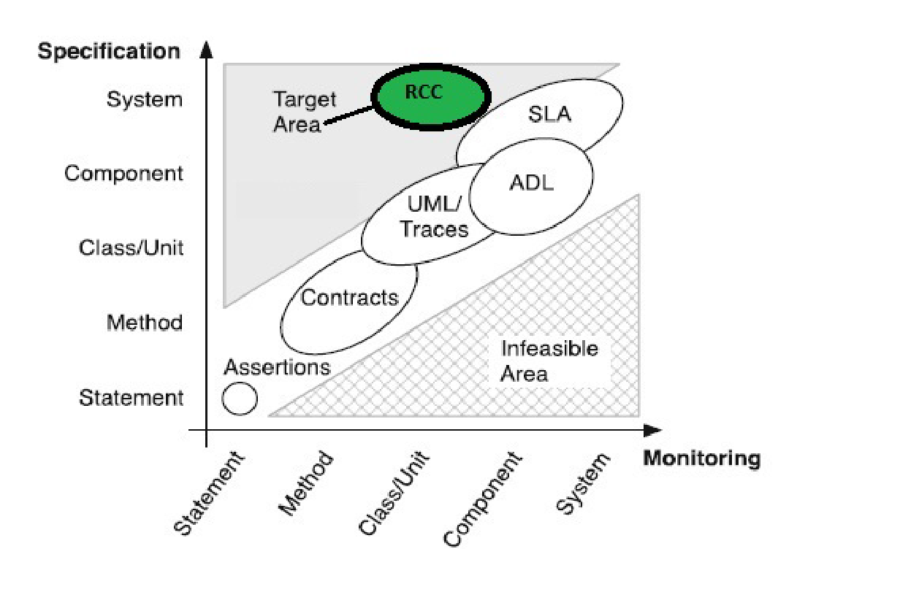
Figure 1: Specification abstraction level vs. runtime monitoring abstraction levels [4].

Software and hardware runtime verifiers have been studied in [5]. While hardware verifiers detect errors at the bus level, before a state change occurs, software verifiers detect errors once a state change has occurred. The presented solution is based on a SW verifier capable of solving this limitation with the advantage of not having to add additional HW or instrument code to be observed.

Introspection allows real-time monitoring of program execution to identify, locate and analyse errors [6] and reflection [7] is the property whereby a component allows observation and control of its own structure and behaviour from outside the component.
The software components of the solution are automatically generated from the UML-SM model. The generation is carried out using the CRESCO platform, which adds reflection and introspection features to these components. Similar solutions exist [8], but none meet the conditions of the CRESCO platform: code in C++, suitable for embedded systems, observable model at runtime. By generating these software components we offer the second contribution of the paper.
The developed verifier is based on contracts to be checked in operation. Most contract-based approaches are mainly used during the design and development phase but there are approaches that suggest the use of contracts at runtime [9-10]. The definition of such contracts can be complex. The present solution proposes to make use of natural language following a certain structure.
Runtime adaptation causes system characteristics to be dynamically modified in response to events, while causing limited disruption to system execution [11]. The present work follows this approach to avoid dangerous situations.
According to [12], it is desirable that run-time verifiers be isolated from the target system to minimise any disruption to the system under test. An "externalised" run-time adaptation system is proposed in [13].

Taking into account the desirable characteristics of real-time verifiers described above, we identify that there are no solutions capable of automatically generating such a verifier, nor are they capable of isolating the functionality of the system and that of the verifier. A solution to the latter is presented as the third contribution of the paper.

Finally, different services of the Arrowhead platform have been analysed [14] and none of them has a Safety Manager role, which is presented in this paper as a fourth contribution.

3.- GENERATION OF REFLECTIVE CONTROLS, CONTRACT VERIFIER and DEPLOYMENT ON THE IoT PLATFORM.

Figure2 shows the architecture of the solution.

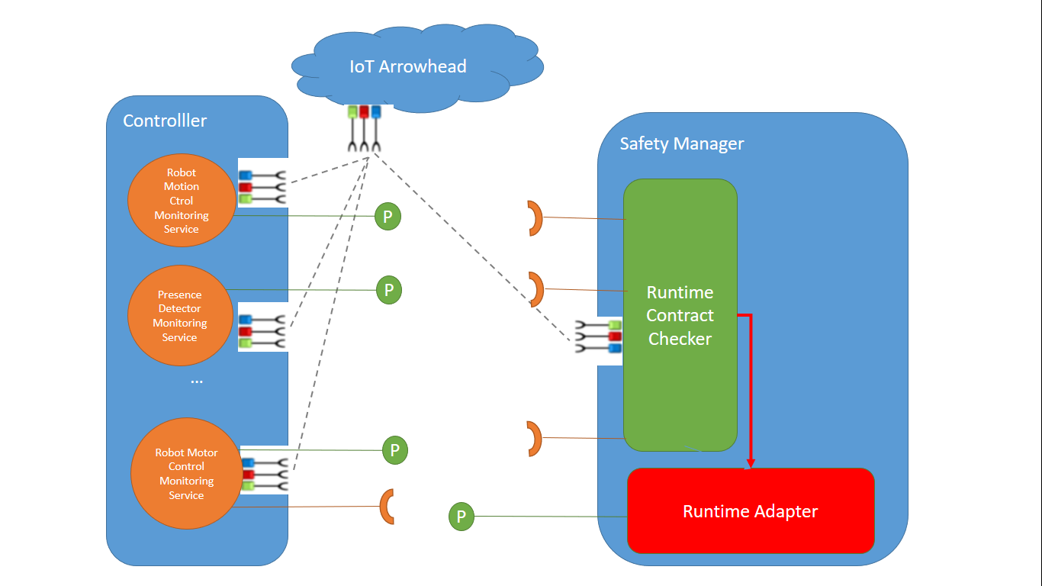
Figure 2 : Solution architecture

3.1. AUTOMATIC GENERATION OF SOFTWARE COMPONENTS: REFLEXIVE DRIVERS
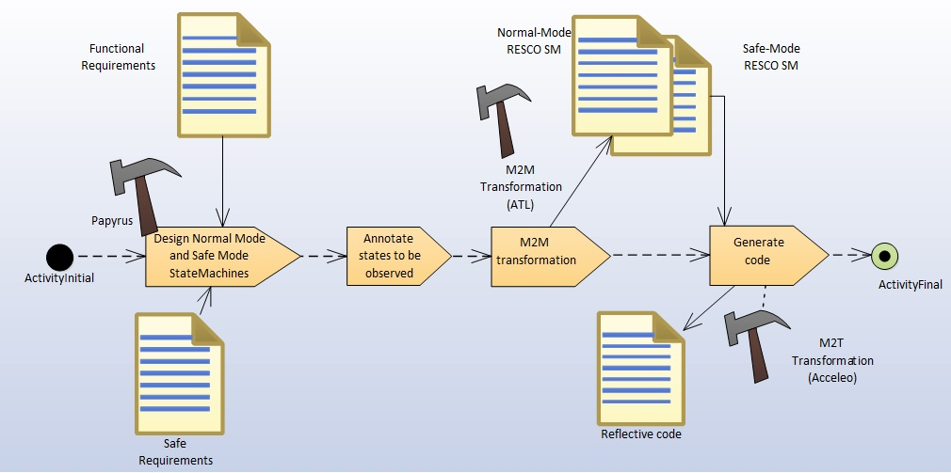
Figure 3 : SPEM diagram: reflective controller generation
The generation process is divided into different phases (Figure3):
- Design (UML-SM) of the component using the Papyrus tool (included in the Eclipse "Modeling Tools" package). In this phase, the observable states are annotated.
- Model transformation (M2M) using ATL. ATL is a model transformation language. Models are transformed by adding the observability feature to those states annotated as observable.
- Code generation. Transformation from model to text (M2T) using Acceleo technology. The generated code is structured in 4 files (Annex 1).
Once we have the code, it is added to the common part of the CRESCO library. We now have the controllers ready for integration and deployment on the IoT platform.

3.2.- AUTOMATIC GENERATION OF THE CONTRACT VERIFIER (RCC)

The second objective is to create an automatic contract generator. This generator has as input a file where the rules that the software components must comply with for the correct functioning of the system are defined and will generate the code to be executed to check the contracts at runtime.

Figure 4 defines this process:

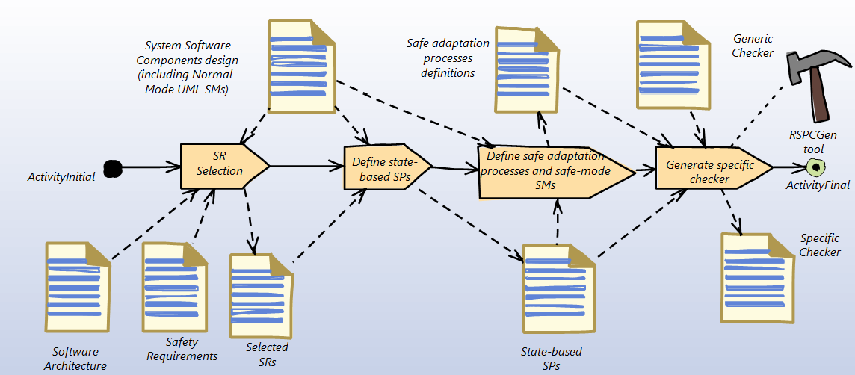
Figure 4 : : SPEM diagram for the automatic verifier generation

- Selection of requirements to be checked: starting from the system architecture, critical system requirements and software component models (UML-SM).
- Writing contracts based on components, states and events to be considered in the contracts. These contracts are written in a file following the following structure:

componentID:currentStatus:nextStatus:eventID implies ( componentID:currentStatus )

Each contract has two parts: 1) up to the keyword "implies" and 2) up to the end of the line. The first part defines the contract for a component that initiates the transition. Such a component may be in a system with more components and a change in its state may affect others. This is where the second part of the contract comes in, defining the states in which the other components must be in order to reliably carry out the transition.

For example: "1:3:5:6 implies ( 2:2 )" to effect a change of state of the component with id=1 from the state with id=3 to the state with id=5 with the event that generates this transition being the event with id=6, implies that the component with id=2 must be in the state with id=2.

- Definition of the adaptation process to be activated when an undesired situation is detected.
- Fourth step: generating C++ code (Annex 2)

This code is integrated in the generic code of the contract verifier.

3.3.- ARROWHEAD SERVICES: SAFETY MANAGER
The next process is to convert them into Arrowhead services and integrate them into this IoT platform.

To validate the proposal, following the same process as in [15], components generated using the CRESCO framework have been servitised to be compatible with the Arrowhead IoT platform. Thus, the information provided by the controllers is offered as services (providers) for monitoring the internal behaviour of the software controllers.

In addition, another service (Safety Manager) Arrowhead has been developed which consumes the information from the CRESCO software components (servitised) and provides this information to the contract verifier. If the information complies with all the contracts in the system, there is no modification. If any contract is not fulfilled, it sends this evidence to the Runtime Adapter module. This module is also an Arrowhead service (provider) that provides information on the adaptations to be carried out in case non-compliances are detected in the verifier (RCC).

4.- EMPIRICAL ASSESSMENT
As set out in the Introduction, these are the questions to be assessed:

PI1: Is RCC an effective tool for detecting errors and unreliable runtime scenarios?

PI2: Does the servitisation of controls and verifiers in the Edge/Cloud help to increase the reliability of systems in industrial plants?

4.1 CASE STUDY: ROBOTIC ARM AND MOTOR CONTROLLER

This case study was based on a robotic arm controller and its motor. The relative system level requirements are as follows:

- A presence sensor enables or disables the robotic arm controller. The robotic arm controller must be enabled before starting the motor;
- The "Robotic Motion Control" component controls and commands the movement of the robot;
- The "Robotic Motor Control" component controls and commands the activation of the motor that will activate the movement of the motor;
- The "Presence Detector" component manages the detection of humans near the robot.

Figure5 and Figure6 show the state machine diagrams of both controllers.
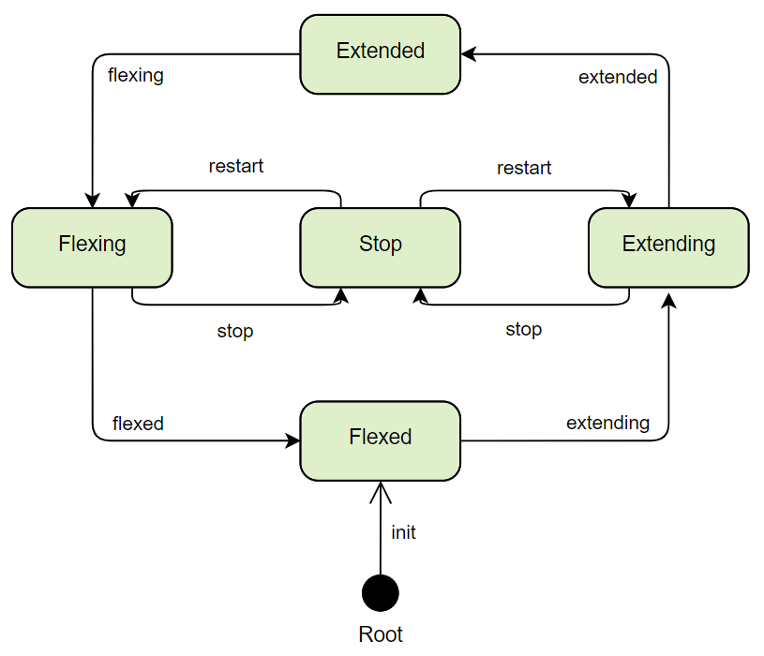
Figure 5 : Robotic Arm Motion Controller

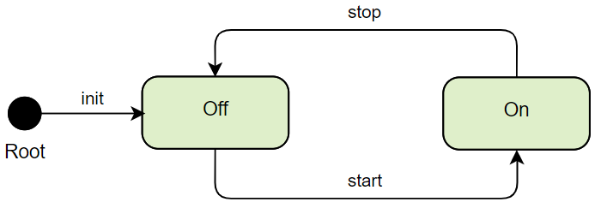
Figure 6 : Robotic Arm Motor Controller
Once the behaviour of the controls has been modelled, and following the process detailed in Figure3, CRESCO software components are generated. These controllers are also converted into Arrowhead services, thus providing the same information through the Arrowhead IoT platform (explained in 3.3).

The contract checker is then created according to the steps in Figure4.
Step 1: Definition of reliability/safety requirements (SR):

- SR1. When the robot is in the Flexing or Extending state, the motor must be in the On state.
- SR2. When the presence detector detects a person at the station, the robot has to go to the Stop state within 1 second.
- SR3. When the motor is in the Off state, the robot must be in the Stop, Extended or Flexed state.

Step 2: Express these requirements as state-based reliability/safety contracts.

List 1: Reliability/Safety Requirements expressed as Safety Contracts

SC1:CRobot. Sflexing or CRobot.Sextending implies CMotor.Son
SC2:CPresencia.Sobst and CMotor.Son implies CRobot.Sstop in 1000
SC3:CMotor.Soff implies CRobot. Sstop or CRobot.Sextended or CRobot.Sflexed

Step 3: Define safeStop processes for each contract.

In this case, a simple process was implemented: when violating any of the contracts, the engine is sent to the Off state.

Step 4: Automatic generation of the CCR.

Once we have the code, the code is integrated with the generic code of the RCC. Finally, the RCC also becomes compatible with the Arrowhead IoT platform. In this case, it has become a service that consumes from the three CRESCO controllers (providers) in order to verify the contracts defined at the system level.

Finally, a module has been added to the verifier, the Runtime Adapter. The RCC, when it detects that a contract is not fulfilled, indicates this to the Runtime Adapter and the latter offers this information as an Arrowhead service. In this use case, the CRESCO component that controls the motor of the robotic arm, in addition to being an information provider, is also capable of consuming the information offered by the Runtime Adapter service. Thus, when the Runtime Adapter informs it that a contract is not fulfilled, the motor controller stops (safeStop adaptation), preventing any anomalous situation.

4.2. EXPERIMENTAL SCENARIO

The experimentation scenario consists of 4 experiments. The code of the software components was automatically generated by the CRESCO framework. Therefore, we cannot simulate certain implementation bugs (C++ coding related bugs defined in MuCPP [16]). Mutations were injected to simulate erroneous transitions in order to evaluate the reliability/safety of the RCC against implementation faults. For transient faults, we generated artificial events.

Table 1 shows the characteristics of each of the experiments. The first experiment was conducted using a correct system. A total of 154 artificial events that generated transient failures were injected and 3 system-level contracts were used (see List 1).

Table 1: Experimentation Scenarios
Experiment | IP Applied | Transient Faults | Number of Mutations | Number of Contracts
Correct System | PI1,PI2 | 154 | 0 | 3
Fault Injection 1 | PI1,PI2 | 125 | 1 | 3
Fault Injection 2 | PI1, PI2 | 125 | 2 | 3
Fault Injection 3 | PI1,PI2 | 125 | 3 | 3

In the following three experiments, 6 mutations of erroneous transitions were inserted. Two of the erroneous transitions were inserted into an unobserved state (Flexed: the target state of the extending event was changed to the Flexing state). The rest of the mutations were made in observed states (e.g. in the Flexing state, the stop event generated an auto-transition) and affecting one of the contracts.

4.3 RESULTS
Table 2 shows the results of Research Question 1.

Table 2: Results PI1: Detection of CCR failures.
Experiment | Implementation Failures (Mutations) | Transient Faults | Number of Safety Violations | Failures detected (%) | Violations Safety detected (%)
Correct System | 0 | 154 | 100 | 100% | 100%
Fault Injection1 | 1 Incorrect Transition (IT) (in observed state (EO)) | 125 | 125 | 100% | 100%
Fault Injection2 | 2TI (1EO, 1 unobserved state (ENO) | 125 | 109 | 87% | 100%
Fault Injection3 | 3TI (2 EO 1 ENO) | 125 | 105 | 84% | 100%
TOTAL | 6 TI (4 EO, 2 ENO) | 529 | 439 | 93% | 100%

The difference between Detected Failures and Detected Safety Violations is that in the former we consider all failures (occurring in observed or unobserved states) and in the latter only those failures that affect contracts.

The RCC detects 93% of fault activations and 100% of fault activations resulting in violations of reliability/safety contracts.

We can deduce that the result of 100% detection of critical situations was to be expected. This is because the states involved in the contracts are observed and evaluated. As for the result of all errors, the more states observed, the more the number increases and the higher the reliability of the systems. But on the other hand, the communication messages and dependency on the IoT infrastructure is increased, which makes the solution less efficient.

For PI2, both the automatically generated reflective controls and the verifier (Safety Manager), followed a servitisation process to meet the interoperability requirements of the Arrowhead IoT platform. The demonstrator was found to be functional and correctly detects artificially introduced faults as well as triggering the adaptation process (safeStop).

4.4. DISCUSSION

The objective of PI1 was to evaluate whether RCC is an effective tool for real-time fault detection. The results show that faults that violate reliability/safety contracts are detected in 100% of the cases. As for PI2, the results show that an IoT solution that protects and ensures the correct functioning of controls (digital industry) is possible.

5. CONCLUSIONS AND FUTURE WORK
This paper presents a runtime checker, RCC, a framework for automatically generating reflective controls and deploying them in services using the Arrowhead IoT platform.

We empirically evaluate the efficiency of RCC for run-time fault detection. The main conclusion is that it detects all reliability/safety related faults thus increasing the robustness of the system. Add that the robustness increases when we increase the number of observed states. This could have limitations in response times. With the new 5G technology, these delays and efficiency issues are not detected as major threats.

Another conclusion is that the RCC generation process is simple: the reliability/safety engineer only has to define the contracts and the safeStop processes. The rest of the process is automatic. The developer of the software components only models the functional aspects of the system. In addition, its possible servitisation (Safety Manager) on an IoT platform has been seen to be effective.

As future lines of research we consider:
- Extend the empirical assessment using other real, industrial use cases.
- Develop a more robust safeStop process manager.
- Provide a tool that helps to systematically add to the safeStop process manager.

ACKNOWLEDGEMENTS

This work has been partially funded by the ADEPTNESS project, ARROWHEAD Tools, and Ikerketa Taldeak of the Basque Government (IT1326-19). ADEPTNESS has received a grant from the European Union Horizon 2020 (Grant Agreement nº871319) and ARROWHEAD Tools from the European Programme ECSEL Joint Undertaking (JU) (Grant Agreement nº826452).

BIBLIOGRAPHY

[1] | P. Koopman, "Challenges In Representing CPS Safety," {Workshop on Developing Dependable and Secure Automotive CPSs from Components, 2011.
[2] | IEC, "61508:Functional safety of electrical/electronic/programmable electronic," 2010.
[3] | M. Brini and e. al., "Complementary methods for designing safety necessities for a Safety-Bag component in experimental autonomous vehicles," National Conference on "Software and Hardware Architectures for Robots Control," 2017.
[4] | M. Pezzé and J. Wuttke, "Model-driven generation of runtime checks for system properties," Int J Softw Tools Technol Transfer, 2016.
[5] | N. Delgado and S. Roach, "A Taxonomy and Catalog of Runtime Software-Fault Monitoring Tools," IEEE Transactions on Software Engineering, 2004.
[6] | M. James, P. Springer, and H. Zima, "Adaptive fault tolerance for manycore based space-borne computing," in European Conference on Parallel Processing. Springer, 2010, pp. 260-274.
[7] | P. Maes, "Concepts and experiments in computational reflection," in ACM Sigplan Notices, vol. 22, no. 12. ACM, 1987, pp. 147-155.
[8] | M. Illarramendi, "Runtime Observable and Adaptable UML State Machine-Based Software Components Generation and Verification: Models@Run.Time Approach," PhD Thesis, 2019.
[9] | K. Östberg and M. Bengtsson, "Run time safety analysis for automotive systems in an open and adaptive environment," SAFECOMP 2013 - ASCoMS Workshop.
[10] | O. Ferrante and e. al., "Monitor-based run-time contract verification of distributed systems," IEEE International Symposium on Industrial Embedded Systems, 2014.
[11] | I. Cassar and A. Francalanza, "Runtime adaptation fo in Runtime Verification. Springer, 2015, pp. 38-54.
[12] | A. Kane, T. Fuhrman and P. Koopman, "Monitor Based Oracles for CPS Testing," Dependable Systems and Networks: Practical Experience Report, 2014.
[13] | D. Garlan and B. Schmerl, "Model-based adaptation for self-healing systems," in Proceedings of the first workshop on Self-healing systems. ACM, 2002, pp. 27-32
[14] | Arrowehad Consoritum "Arrowhead Core Systems & Services", https://arrowhead.eu/eclipse-arrowhead/this-is-it/core-systems-services/ (2021-09-14)
[15] | Iñigo Aldalur et al. <<Advantages of Arrowhead Framework for the Machine Tooling Industry>>. 46th Annual Conference of the IEEE Industrial Electronics Society. Singapore. October 2020. Pp. 4511-4518
[16] | P. Delgado-Pérez, I. Medina-Bulo, F. Palomo-Lozano, A. García-Domínguez, and J. J. Domínguez-Jiménez, "Assessment of class mutation operators for C ++ with the MuCPP mutation system," Information and Software Technology, 2017.

