35th International Electric Vehicle Symposium and Exhibition (EVS35)
Oslo, Norway, June 11-15, 2022
Development and Validation of a cloud-based Digital Twin Platform of a Li-ion Batteries by means of Cell-Level Modelling
Olatz Lizaso-Eguileta ^{1,2,3*}, Egoitz Martinez-Laserna ¹, Eduardo Miguel ¹,
Unai Iraola ², Igor Cantero ³
¹Ikerlan Technology Research Centre (BRTA), Arrasate/Mondragon, Spain,
*olizaso@ikerlan.es
²Electronics and Computing Department Mondragon Unibertsitatea, Faculty of Engineering, Arrasate/Mondragon, Spain
³R&D Department, Cegasa Energía, Miñano (Vitoria), Spain
Summary
In this paper, a battery cell's electrical and thermal models have been parameterised and then validated on a Digital Twin Simulation Platform. Furthermore, these models have been integrated to analyse thermo-electric aspects based on experimental data by comparative analysis. The final model analyses the state of the batteries in real-time.
Keywords: enter, in italic type up to five keywords from the provided list. The keywords on the paper shall match those selected when submitting

Introduction
Maximising Li-ion battery (LIB) lifetime is a technical challenge due to the strong coupling between battery longevity and battery operating conditions such as temperature, charging profile or State of Charge (SOC) operating range [1]. Therefore, good battery monitoring and control under a wide variety of operating conditions is essential to maximise the usability and lifetime of the batteries.
The internal states of a LIB are not directly measurable in situ by conventional sensors, so advanced algorithms are developed to quantify and estimate these X states. SoC and State of Health (SoH) are some of the typical key X states (SoX) that are tracked in the Battery Management System (BMS). The monitoring of SoX allows a correct and safe operation of the battery. In addition, they provide essential information about the energy available. Meanwhile, it enables advanced control systems' designing operational strategies, advanced fault or safety condition diagnosis, thermal management or optimal control of battery performance.
The information provided by these states allows the design of operational strategies, the diagnosis of error conditions, thermal management, or optimal control of loads to prolong battery lifetime. Accurate and robust estimation algorithms are often based on historical data, requiring greater computational power and memory that conventional industrial BMS solutions lack [2]. To overcome these challenges, the required performance of the BMS can be extended by means of cloud computing and IoT-based technology.
With batteries becoming increasingly connected due to the use of Internet of Things (IoT) technologies, there is the possibility of collecting real operation data once the batteries are deployed. In this context, Digital Twins (DT) [3] are created as digital replicas of the battery with close interaction with its virtual counterpart and the aggregation of in-field data over their entire lifetime.
Creating a battery DT environment in which the models, data and Machine Learning (ML) tools are integrated, makes possible to have a cloud BMS (cBMS) with an enhanced intelligence. This enables the application of key communication and networking technologies such as virtualisation, real-time monitoring and paves the way towards improved asset management and subsequently a longer battery lifetime.
In this work… (esplikatu parte diferentek)

Digital Twin Simulation Platform
Lithium Werks 26650 cells (Figure 1) will be used in this paper, and their main characteristics are summarised in Table 1.
Table 1: Lithium Werks 26650 cell characteristics
Nominal Ratings
Voltage |  | 3.3_V
Capacity |  | 2.5_Ah
Internal resistance |  | 6_mΩ
Temperature range |  | -30 – 55 ºC

Figure1: Lithium Werks 26650 cell
Concerning issues of performance and lifetime prediction of LIBs, models of different nature are often used. These typically describe the voltage response to a current load, the thermal performance and the evolution of capacity/resistance over the lifetime of the cells. There are currently a diversity of approaches in each type of models, and in the way they are integrated.

Electric Model of the Cell
Batteries are often modelled to describe the voltage response of the cells according to the different physical phenomena occurring in them [3]. Equivalent circuit models (ECMs) are one of the most common methods for electrical modelling of batteries. ECMs use electrical elements such as resistors and capacitors, as well as an open circuit voltage (OCV) versus SoC profiles to reproduce the voltage response of a battery. ECMs require complicated parameter identification to represent the non-linear nature of the battery cells. They are lighter than electrochemical models and, depending on the specific battery chemistry and desired modelling accuracy, a different number of RC blocks can be used. In this work, an ECM with two RC phases has been chosen, which also considers the battery hysteresis. It has been chosen for its trade-off between accuracy and complexity versus computational cost. Fig. 1 describes the ECM to be implemented in the DTSP.
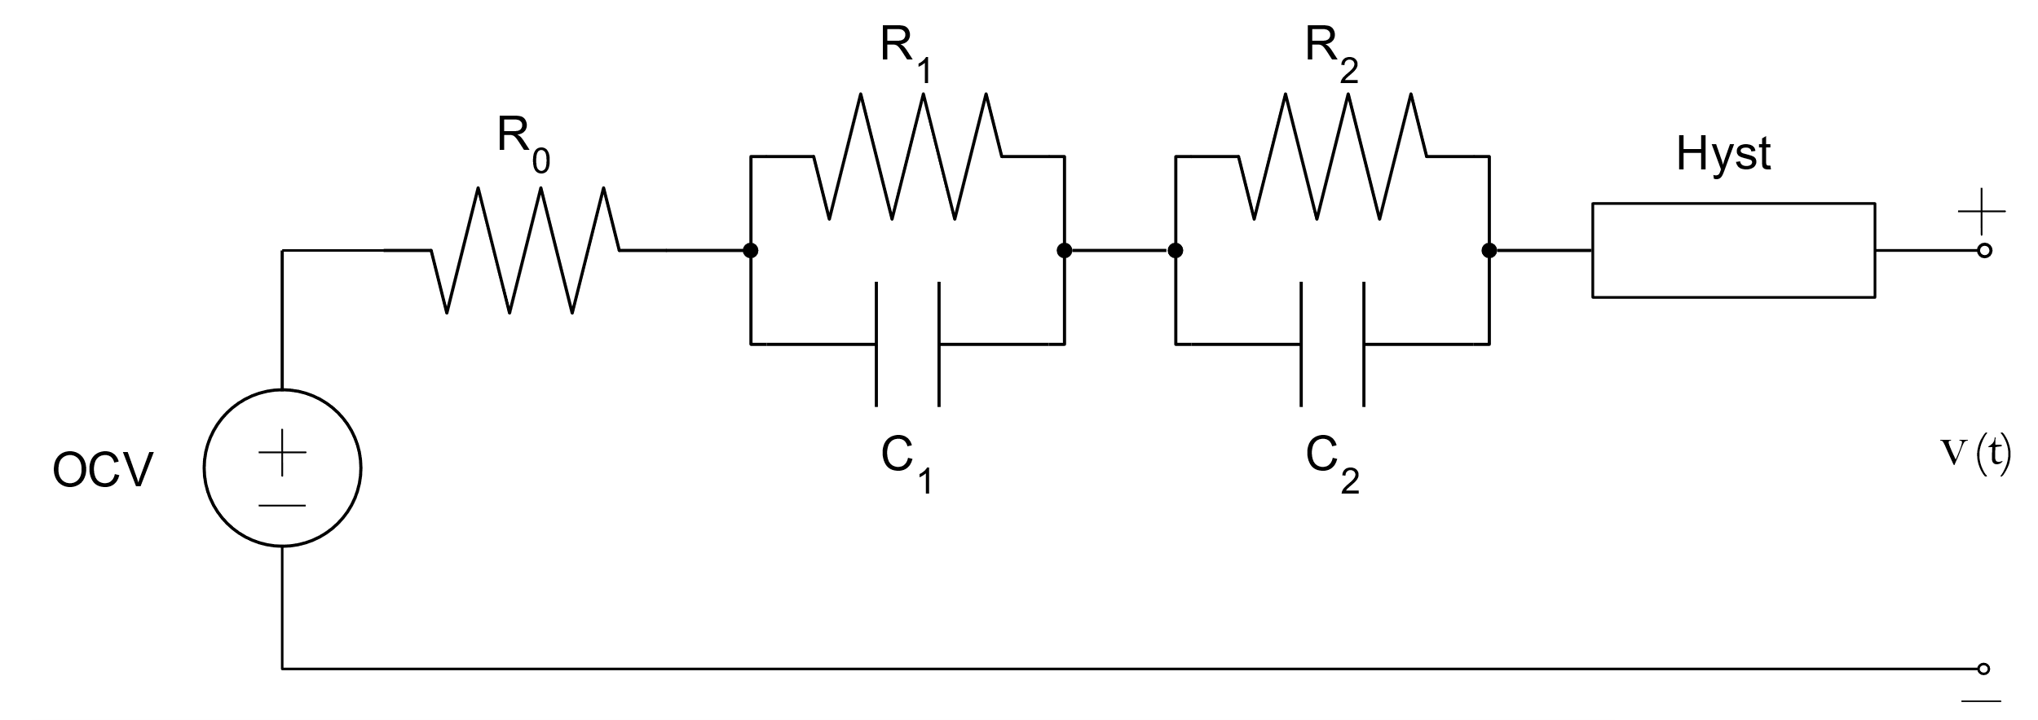
Figure 2: Digital Twin Electric Equivalent Circuit Model.
The different parameters of the model are influenced by the temperature and SoC of the LIB. These parameters are obtained by different laboratory tests such as the Hybrid Pulse Power Test (HPPT) or the OCV vs SoC test. They are then described in a look-up table and the model updates the value of the parameters at each time step. The states of diffusion voltage, the hysteresis voltage and the internal resistance of the cell are calculated following the same procedure as presented in [4].
The instantaneous hysteresis component changes immediately when the sign of input current changes. This hysteresis voltage is modelled by $s(k)$:
$$s(k)=\left\{\begin{aligned}sgn(i(k)), &\left|i(k)\right|>0 \\ s(k-1), &otherwise\end{aligned}\right.$$ | (1)
$M$ is the value of the maximum positive and negative value of hysteresis at any SoC. On the other hand, $M_{0}$ is the instantaneous hysteresis. Therefore, full hysteresis voltage will be defined as $\left(M_{0}s(k)+Mh(k)\right)$. The output equation of the model considers all the phenomena described above. The equation is defined in (4).
$$v(k)=OCV(k)+M_{0}s(k)+Mh(k)-R_{1}i_{R_{1}}(k)-R_{2}i_{R_{2}}(k)-R_{0}i(k)$$ | (2)
The cell states are estimated indirectly from measurement data from laboratory tests. The BMS must be able to choice the model parameters at each time step such as cell capacities or resistances and the different cell states such as state of charge or diffusion voltage. Estimation of SoC is difficult because it is time-dependent, highly non-linear depending on battery chemistry and variable with temperature. Traditional methods for estimating SoC include the voltage-based method (open-circuit voltage [OCV]) [5] and the current-based method (coulomb counting) [6] . These types of methods for SoC estimation are easy to implement, however, they have their limitations. The OCV method ignores the effects of impedance, diffusion and hysteresis voltage. On the other hand, the Coulomb Counting method is a open-loop type of estimation with a cumulative error.
Therefore, more advanced methods are added to this type of estimation techniques, such as Kalman filters, for example. In this work, a Sigma Point Kalman Filter (SPKF) has been added to the ECM model. This algorithm estimates the SOC value based on the measured voltage, current and previously estimated SOC. It has a prediction sub step and a correction sub step that correct predictions to produce a state estimate together with their confidence limits in each measurement interval. More detailed information can be found in [7], [8].

Thermal Model of the Cell
Thermal models are used to describe the thermal gradient of LIBs. They can be used to estimate the temperature at different points in the cell without additional temperature sensors that increase the cost of the cell. The chosen and developed thermal lumped model is described in Fig. 2.
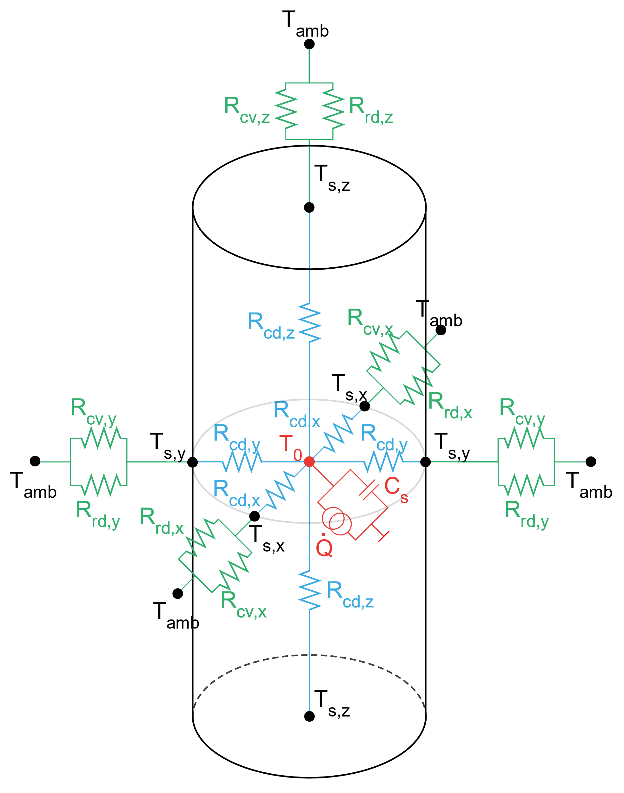
Figure 3: Digital Twin Thermal Lumped Model
First, the heat generated by each cell $\left(\dot{Q}\right)$ and the accumulated heat $\left(C_{s}\right)$ are calculated. In addition, the heat transferred to the cell surface by conduction $\left(Q_{cd,i}\right)$ is calculated in all three dimensions. This heat transferred to each cell surface is dissipated by convection $\left(Q_{cv,i}\right)$ and radiation $\left(Q_{rd,i}\right)$. This heat power is calculated with the resistance corresponding to each of the cell geometries (radial and axial in this case). The thermodynamic energy balance of lithium-ion batteries has been discussed in detail by Bernardi et al. []. However, not all processes have been taken into account in this work, only heat generation, heat storage capacity, heat transfer and finally heat dissipation.
The generation of heat ($q_{gen}$) is given by the result of the transfer of charges releasing irreversible thermal energy, as well as by the reversible electro-chemical reactions in the cell. A simplified form of the equation proposed by Bernardi et al. can be used as an expression of the heat source in the lithium-ion cell tested in this work by the following equation
$$q_{gen}=I\left(V-U^{avg}\right)+IT\frac{dU^{avg}}{dT}=I^{2}∙R_{0}+I∙T∙EHC$$ | (3)
where, $I$ is the current through the cell in Amperes; $V$ is the terminal voltage of the cell in Volts; $U^{avg}$ is the average $OCV$ in Volts; $T$ is the temperature of the cell in degrees Celsius ($℃$) and $\left({{dU}^{avg}}/{dT}\right)$ is the Entropic Heat Coefficient ($EHC$) in $\left(Volts/℃\right)$ defined by the changes of the equilibrium potential with temperature.
Irreversible heat is defined as the heat which behaves as an exothermic process regardless of whether the cell is charging or discharging. On the other hand, the reversible heat is the heat that defines the exothermic or endothermic performance of the cell. The EHC defines the amount of heat generated or absorbed for each SoC step in the charging or discharging processes. With positive EHC values, a cell will generate heat during charging (positive current value) while it will absorb heat during discharging (negative current value). The opposite happens with negative EHC values. EHC changes are subject to each cell and must be studied for each characterisation [9].
In Fig 3, the capacitance $C_{P}$ describes the accumulated heat of the cell resulting in the temperature rise.
$$q_{accum}=m·c_{p}·∆T$$ | (4)
The heat, generated by the processes described above, flows through the battery materials by conduction. The corresponding heat flow ($q_{cond}$) in the materials resulting from thermal conduction is a function of the location in the module.
$$q_{cond}=k_{x}A\frac{∆T}{∆x}+k_{y}A\frac{∆T}{∆y}+k_{z}A\frac{∆T}{∆z}$$ | (5)
where, $k=k (x,y,z)$ is the coefficient of thermal conduction expressed in $\left[\frac{W}{m·k}\right]$, describing a specific property of each material used to characterise the heat transport in stationary rate [10]; $A$ is the area through which heat flows perpendicularly at a stationary rate expressed in [$m^{2}$]; and $\frac{∆T}{∆x}$ is the temperature gradient in [$K$] in x direction.
This heat transferred to the cell surface is then dissipated by convection ($Q_{cv,i}$) and radiation ($Q_{rd,i}$). In this work, convection occurs naturally and the temperature change comes from the difference in density inside the fluid (i.e. air). The amount of heat transferred by convection is expressed in equation (3).
$$q_{conv}=hA∆T$$ | (6)
where, $h$ is the transfer coefficient of thermal convection expressed in $\left[\frac{W}{m^{2}k}\right]$, describing a specific property of the fluid flow and depends on several factors such as natural or forced convection, location, geometry, surface roughness and the medium surrounding the battery expressed in $\left[m^{2}\right]$; and $∆T$ is the difference in temperature between the surface of the solid and the fluid expressed in.
On the other hand, heat transfer by radiation ($q_{rad}$) between two grey bodies is calculated by
$$q_{rad}=εσA\left({T_{s}}^{4}-{T_{e}}^{4}\right)$$ | (7)
where, $ε$ is the surface emissivity of the considered specific material, being a dimensionless number (with a value between 0 and 1) and relates the ability of a body to radiate thermal heat; $σ$ term is the Stefan-Boltzmann constant equivalent to $5.67·{10}^{-8}\left[\frac{W}{m^{2}K^{4}}\right]$; $A$ is the surface area of the body expressed in $\left[m^{2}\right]$; and $T_{s}$ and $T_{e}$ are the surface temperatures of the two contiguous bodies that transfer heat by radiation between them.
The equations describing each of the thermal phenomena are described as
$$q_{accu}=q_{gen}-q_{cond}$$ | (8)
$$q_{cond,i}=q_{conv,i}+q_{rad,i}$$ | (9)
where, $q_{accu}$ is the heat accumulated between the current $k$ and the previous $k$ ($k-1$), $q_{gen}$ is the heat generated by the current flowing through the cell, $q_{cond}$ is the heat transferred by conduction from the centre to the surfaces of the cell and $q_{conv}$ and $q_{rad}$ is this conductive heat dissipation via convection and radiation. The index $i$ represents each of the three dimensions through which the heat is transferred.

Integration of Cell Models
The models previously presented are integrated to develop a DTSP based on cloud computing. This platform is destined to be the digital replica of the LIB, where different battery states can be estimated (SoX) to later enable a variety of Digital Services and, thereby, optimise battery operation through its entire lifecycle. After analysing the inputs, outputs and parameters required by each of these models, it has been studied which characteristics are shared and how the basic properties of each model influence the other. As shown, both models require a current profile as input data and also need the temperature and the SoC from the previous step. In terms of parameters, they share a common internal resistance parameter of the cell.
For the estimated values of the cell-level models, the voltage calculated by the electrical model will be used to estimate the SoC of the battery, which will be used by both the thermal model and the feedback of the model itself. The same is true for the thermal model, which calculates the cell temperature, which is used as input for the electrical model and for the thermal model itself. Based on all this, it can be seen that the models feedback their calculations for more accurate estimations and predictions. To this end, a simulation platform is proposed for this battery with the aim of performing full monitoring in the electrical and thermal fields.
Figure 4: Digital Twin Simulation Platform

Preliminary Validation Results
The DTSP validation will be done both at the cell level and battery module level. However, this paper mainly focuses on the former validation stage. For that purpose, different electric and thermal characterisation tests at Beginning of Life (BoL) have been carried out.
For the electrical model validation, a HPPC test has been performed where different C-rate pulses have been applied to the cells at different points of the SoC, both in charge and discharge. On the other hand, the thermal model validation has been performed against a cell capacity test where the measured temperatures are compared with the thermal model estimation.

Electric Model Validation Results
To examine and compare the performance of the proposed algorithms, a discrete-time state-space model applied to the battery cells has first been defined. Tests were performed in the laboratory to adjust the parameters of the cell model, and then tests were performed on another cell to see how these models fit the cell. For the tests, a climatic chamber (CTS, Clima Temperatur Systeme) was used for the experiments requiring a constant temperature and a programmable cycler Industrial Battery Tester.
The cell test realised was a sequence of 4 charge and discharge pulses (of 2.5 A and 1.25 A) spread over the SOC range of 90-10%, all at ambient temperature of 25°C. Fig 5(a) represents the SoC as a function of time in charging the cell, the measured voltages and voltage estimation by the model in Fig 5(b) and finally in Fig 5(c) the absolute error of the model in mV.
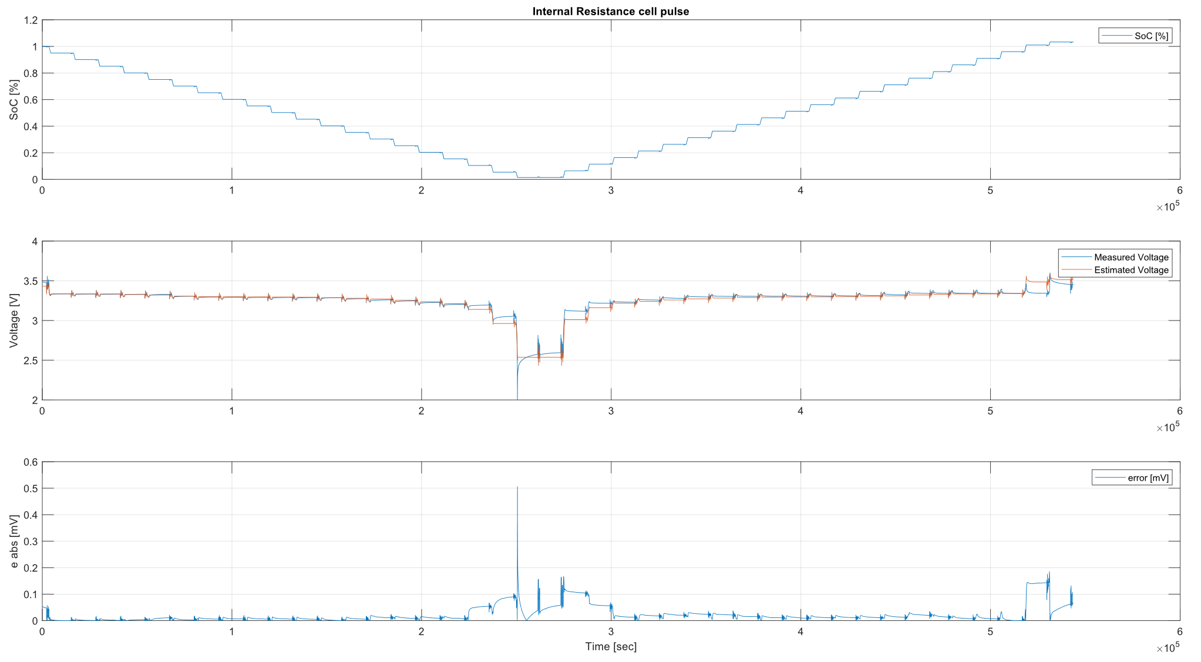
Figure 5: Results of ECM at 25 ºC
The actual voltage value (blue line) was compared with the predicted voltage value (orange line) for the tested data. The model fit has been judged by comparing the estimation error (equal to the cell voltage minus the model voltage) and a very close agreement is observed, especially during the dynamic part of the test. The mean absolute error of the model is 0.0244 mV and the maximum error of 0.5063 mV.
On the other hand, the test has been repeated with an identical current profile at an ambient chamber temperature of 45ºC. Figure 6 shows the equivalent results obtained by the electrical model under the new conditions.
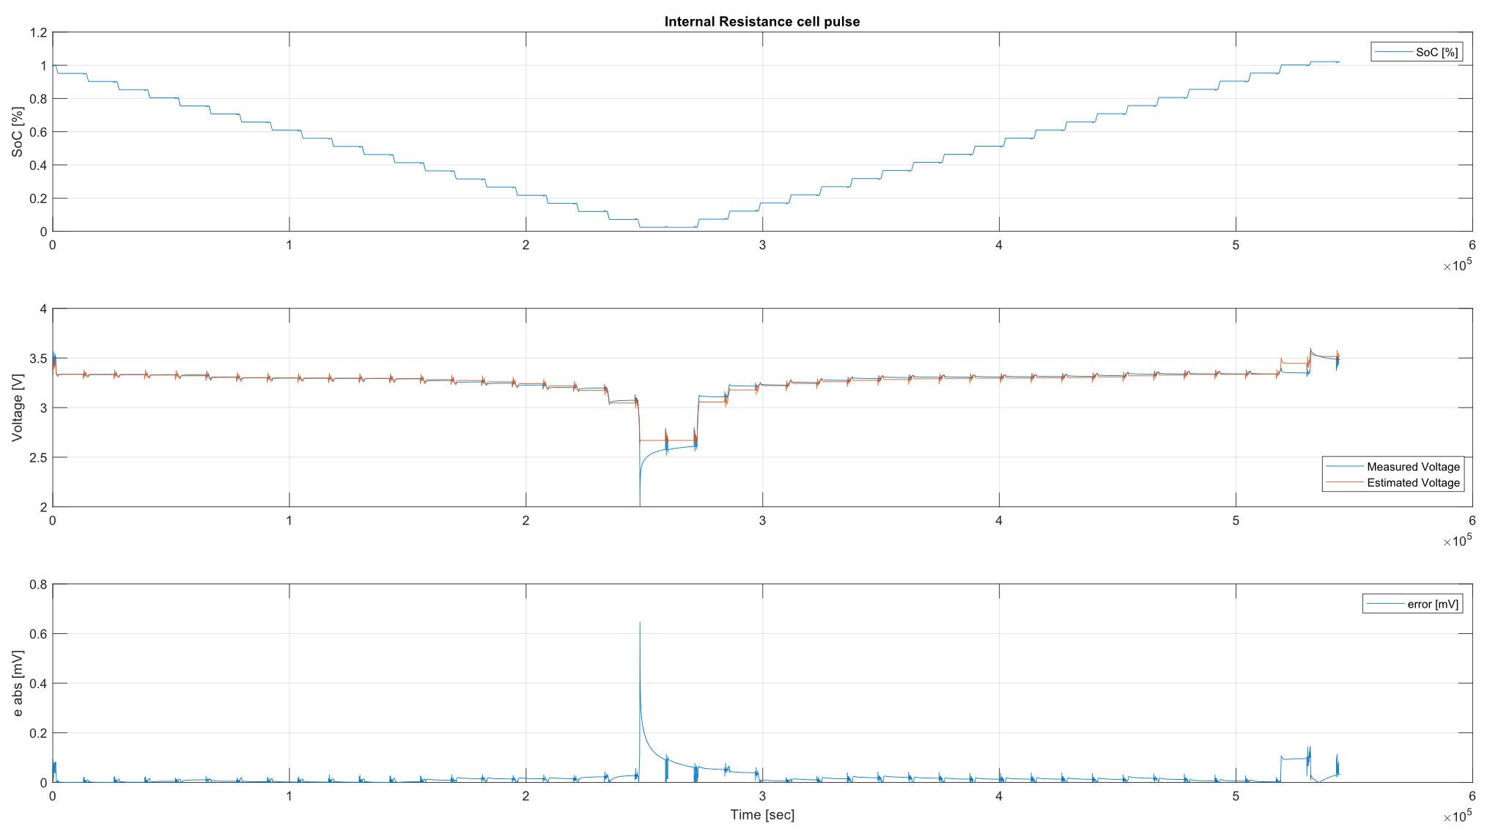
Figure 5: Results of ECM at 45 ºC
The model has mostly predicted the correct voltage value with a mean absolute error of 0.0182 mV and the maximum error of 0.6494 mV. With these results, the electrical model of the system is well suited to the simulation needs of the battery module.

Thermal Model Validation Results
In this part, the identified thermal behaviour of the selected cell has been further analysed by means of loads at different C-rates. In this way, the expected performance and the thermal response measured during the testing of the cell could be verified. 1C load of two complete cycles of the cell has been performed in a thermal chamber at a constant ambient temperature. The thermal chamber used (CTS, Clima Temperatur Systeme) has an accuracy of ±0.3 K to maintain the desired ambient temperature. The temperature mapping of the cell temperature was performed using the Agilent and a T-type thermocouple for each cell surface and the IBT was used to load the cells. The same test was then repeated, in this case at 4C.
The thermal model calculates an energy balance at each time step to optimise the temperatures of every surface of the cell. The energy balance is performed using the Newton Raphson optimisation method Fig. 6(a) represents the SoC as a function of the cell, the measured temperatures and the temperature estimation by the model in Fig. 6(b) and finally in Fig. 6(c) the absolute error of the model in K.
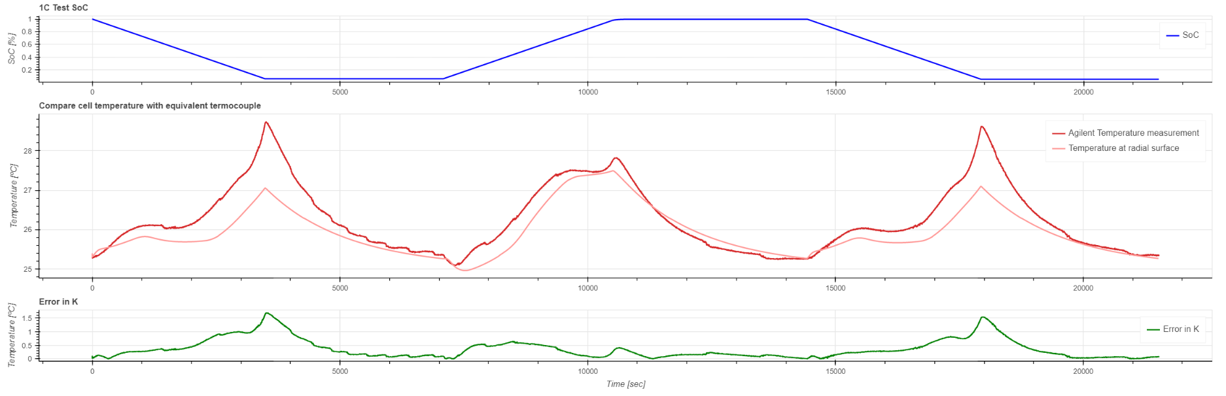
Figure 6: Results of Lumped Model for 1C current profile.
The model has an average error of 0.3609 ºC and the maximum error of 1.7093 ºC. This same test has been repeated in this case at 4C currents of the cell. Fig. 7(a) represents the SoC as a function of the cell, the measured temperatures and the temperature estimation by the model in Fig. 7(b) and finally in Fig. 7(c) the absolute error of the model in ºC.
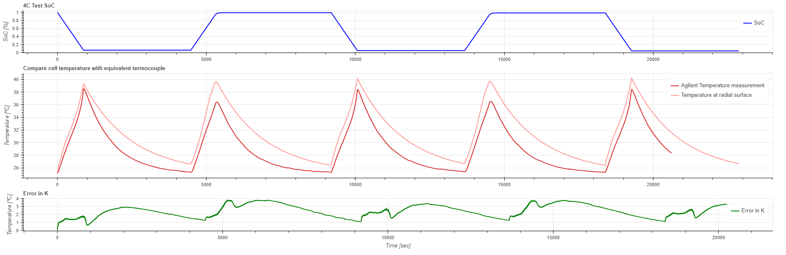
Figure 7: Results of Lumped Model for 4C current profile.
The model was not trained for such high currents, however it showed an acceptable accuracy with an average error of 2.3405 ºC and the maximum error of 3.8244 ºC. Thus, it is evident that the model is able to predict the temperature at different operating C-rates.

Implementation of the DTSP in the Cloud
To develop module-level battery models which consider each of the cells separately, this section will describe in detail the proposed module-level modelling approach. Most of the electrical and thermal battery modelling works in the literature are designed and validated at the cell level. However, the actual performance of a DTSP depends on its ability to model LIB performance at the module level. To implement this methodology, the proposed hardware is presented in Figure 8.
Figure 8: Schematic diagram of the proposed DTSP validation platform
A battery module is composed of a series of cells connected in series or parallel. However, all these cells rarely operate in perfect balance when it is operating, and this affects the final useful energy of the battery. For these reasons, it is necessary to estimate the SoX of each cell and then estimate the equivalent response of all the cells. To this end, this work is ongoing on the extrapolation from cell-level models to full module-level models.
In this line, it is proposed to develop the thermal model presented in this work and extrapolate it to make its estimations at the module level. By implementing at the module level, the heat transferred between all the cells is considered. To estimate the temperature distribution within the module, the common points of the thermal equivalent circuits of the cells are joined according to the module topology and a meshed circuit is created. This implies that the operations to calculate the energy balance are multiplied by the number of cells. With this information, the equivalent temperature of all surfaces and the core temperature of each cell are obtained. These are used to decide the equivalent temperature of each cell. The thermal model at module level uses the updated voltage and SoC information (information estimated by the electrical model). In turn, temperature is known to influence the electrical behaviour of the cell, so the temperatures estimated and updated by the thermal model will be used as input for the electrical models at the cell level. The electrical model is implemented for each cell and co-simulated. The results are extrapolated to the module level taking into account some previously defined criteria for the estimation of the Equivalent Module Voltage ($EMV$) and this successively to estimate the equivalent SoC of the whole module.
The DTSP will provide a clearer representation of the temperature distribution over a large number of points within the module, which is usually not affordable as LIB modules typically have a small number of temperature sensors. In addition, this platform allows for a more accurate estimation of the SoC of each cell in the module. This, together with the temperature distribution, can lead to more accurate SoH and RUL estimates. However, running the thermal model at the module level (the calculation of the energy balance multiplied by the number of cells) together with electrical co-simulations at the cell level requires considerable computing power that the battery BMS may not be able to provide.
To overcome these challenges, the required performance of the BMS can be increased by implementing it with cloud computing technologies. With this computational capacity, continuous monitoring with different state estimation algorithms is possible. On the other hand, by being able to track historical LIB data from multiple energy storage systems deployed in different applications, anomalies in LIB operation can be detected. By predicting and detecting failures, the safety and reliability of the entire LIB system can be improved.
Thus, Cloud Computing technology will be used for the implementation of the designed DT. With the use of the Cloud, the execution time will be greatly reduced and this will allow a real-time operation. In addition, with the results obtained from the models, a database of historical data will be created and this will allow the monitoring of the LIBs in real time. To develop the Cloud, it has been decided to use the services offered by the Amazon Web Services platform. The developed architecture is presented in Figure 9.
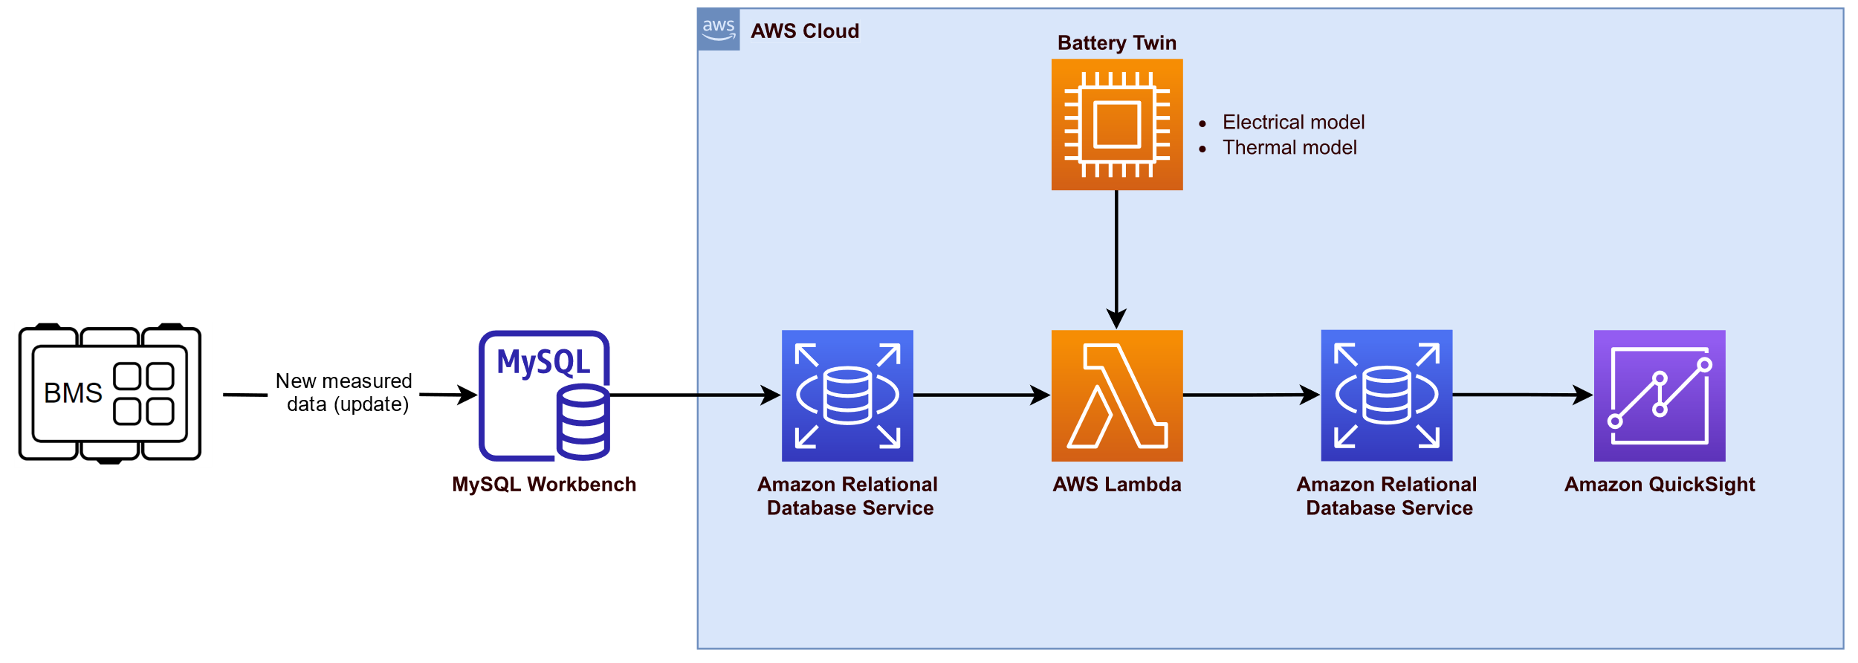
Figure 9: DTSP Cloud schematic architecture.
Depending on the needs of the application, it has been decided to use the Lambda service for code execution. On the other hand, the MySQL database is being used to store the results. Finally, a visualisation service (Amazon Quick Sight) is used, which will be connected to the database, so that the data obtained and stored can be visualised in real time.

Conclusions
The electric and thermal LIB models were validated under experimental data obtained in laboratory tests in a DTSP framework at the cell level. Results obtained highlight the tight coupling among models. Thereby, in order to obtain a more precise model at a module level, it is not enough with extrapolating the results of an average cell to the whole module.
The DTSP framework here described takes advantage of extended cloud computation capabilities to extrapolate individual battery models to a battery module level, ultimately allowing extended monitoring capabilities. In addition, the devised validation platform, which aims to test the performance of the models to be implemented, is also presented. The process of implementing the module-level models described here is still ongoing. The results of the modelling approach and the validation results will be disseminated in future publications.

References
[1] J. M. Reniers, G. Mulder, and D. A. Howey, “Review and Performance Comparison of Mechanical-Chemical Degradation Models for Lithium-Ion Batteries,” J. Electrochem. Soc., vol. 166, no. 14, pp. A3189–A3200, Sep. 2019, doi: 10.1149/2.0281914jes.
[2] M. Lucu, E. Martinez-Laserna, I. Gandiaga, and H. Camblong, “A critical review on self-adaptive Li-ion battery ageing models,” J. Power Sources, vol. 401, no. March, pp. 85–101, 2018, doi: 10.1016/j.jpowsour.2018.08.064.
[3] B. Wu, W. D. Widanage, S. Yang, and X. Liu, “Battery digital twins: Perspectives on the fusion of models, data and artificial intelligence for smart battery management systems,” Energy AI, vol. 1, p. 100016, 2020, doi: 10.1016/j.egyai.2020.100016.
[4] O. Lizaso-Eguileta, E. Martinez-Laserna, M. Rivas, E. Miguel, U. Iraola, and I. Cantero, “Module-Level Modelling Approach for a Cloudbased Digital Twin Platform for Li-Ion Batteries,” 2021 IEEE Veh. Power Propuls. Conf. VPPC 2021 - Proc., 2021, doi: 10.1109/VPPC53923.2021.9699271.
[5] D. Gong, Y. Gao, and Y. Kou, “Parameter and State of Charge Estimation Simultaneously for Lithium-Ion Battery Based on Improved Open Circuit Voltage Estimation Method,” Energy Technol., vol. 9, no. 9, pp. 1–18, 2021, doi: 10.1002/ente.202100235.
[6] C. Forgez, D. Vinh Do, G. Friedrich, M. Morcrette, and C. Delacourt, “Thermal modeling of a cylindrical LiFePO4/graphite lithium-ion battery,” J. Power Sources, vol. 195, no. 9, pp. 2961–2968, May 2010, doi: 10.1016/j.jpowsour.2009.10.105.
[7] G. L. Plett, “Sigma-point Kalman filtering for battery management systems of LiPB-based HEV battery packs - Part 2: Simultaneous state and parameter estimation,” J. Power Sources, vol. 161, no. 2, pp. 1369–1384, Oct. 2006, doi: 10.1016/j.jpowsour.2006.06.004.
[8] G. L. Plett, “Sigma-point Kalman filtering for battery management systems of LiPB-based HEV battery packs. Part 1: Introduction and state estimation,” J. Power Sources, vol. 161, no. 2, pp. 1356–1368, 2006, doi: 10.1016/j.jpowsour.2006.06.003.
[9] N. Nieto et al., “Thermal Modeling of Large Format Lithium-Ion Cells,” J. Electrochem. Soc., vol. 160, no. 2, pp. A212–A217, Nov. 2013, doi: 10.1149/2.042302jes.
[10] D. J. Becker, T. Wetzel, and D. Werner, “Thermal conductivity of Li-ion batteries and their electrode con fi gurations e A novel combination of modelling and experimental approach,” vol. 364, pp. 72–83, 2017, doi: 10.1016/j.jpowsour.2017.07.105.

Authors
 | Olatz Lizaso received the B.Sc. in Renewable Energies Engineering and the M.Sc. in Integration of Renewable Energies in the Electric System from the University of the Basque Country (UPV/EHU), Spain, in 2018 and 2019, respectively. In 2019 she joined IKERLAN Technology Research Centre (BRTA), Arrasate-Mondragon, Spain, where she is currently working toward the PhD degree in the Energy Storage and Management department and in collaboration with the University of Mondragon (MU), Spain. Her research focuses on characterisation and modelling energy storage systems, particularly lithium-ion batteries, both at the cell and module levels.
 | Dr. Egoitz Martinez-Laserna [M]: received his M.Sc in Electronic Engineering from the University of Mondragon, Spain, in 2013. He joined the Energy Business Unit of IKERLAN Technological Research Centre, Spain, in 2013. He obtained his Ph.D. (Cum Laude) in Engineering with international merit in 2017, focused on 2nd life battery performance, sizing and integration. His research interests include electrochemical energy storage systems, electric vehicles, state estimation algorithms, energy management and BMS design. He has been co-author of various scientific publications and has contributed to multiple international conferences. Since 2020 he is the coordinator of the H2020-LC-BAT-10 project LIBERTY.
 | Eduardo Miguel
 | Dr. Unai Iraola obtained his Doctor degree from Mondragon University in 07/2014 in the field of the electro-thermal optimization of battery-based energy storage systems for power applications. After defending his thesis work in 2014, Dr. Iraola continues working at the Faculty of Engineering of Mondragon University as a Research Professor. He is working both in private and public projects and he has supervised different PhD works until now. Dr. Iraola´s current research area focuses on energy storage systems technologies, mainly, lead acid, lithium-ion and solid-state batteries. His research is mainly focused on physics-based battery modeling and implementation within BMS systems with the objective of minimizing degradation via modular battery packs.
 | Igor Cantero

